Abstract

Efficient traffic flow prediction is crucial for effective traffic management and congestion reduction in urban areas. However, traditional statistical models often struggle to accurately capture the intricate dynamics of vehicular traffic flow, particularly under dynamic conditions. In this research project, we propose a novel approach that leverages deep learning techniques, specifically Long Short-Term Memory (LSTM) neural networks, AdaBoost, and gradient descent, to enhance the accuracy of traffic flow predictions .By harnessing historical traffic data, our model generates precise predictions for the next time step, empowering traffic managers to optimize signal timings and proactively reroute traffic. To boost the model\'s performance, we incorporate AdaBoost, which integrates LSTM predictions as additional input features. We evaluate the accuracy of our model using mean absolute error (MAE) and R2 score techniques, comparing the predicted traffic flow against the actual traffic flow .Experimental results demonstrate that our proposed model outperforms traditional statistical models, exhibiting lower MAE and higher R2 scores. This indicates its efficacy in accurately predicting traffic flow and presents a promising solution for traffic management and congestion reduction. Our research contributes to the advancement of traffic flow prediction models by offering a more reliable and accurate approach. Future work may explore the integration of real- time data streams and external factors, such as weather conditions and events, to further enhance prediction accuracy and effectively address dynamic traffic situations. By optimizing traffic management strategies, reducing congestion, and improving overall traffic flow efficiency, our proposed model holds significant potential for improving urban traffic conditions.

A basic architecture that serves as a launchpad for feature enhancements and pservice upgrades will integrate the following components:

* ***Sensors*** for collecting data and sending it to a centralized cloud platform
* ***Actuators*** for physical devices to make necessary adjustments like – restricting the water supply in pipelines with leakages or dimming & brightening streetlights based on weather conditions.
* ***Field gateways*** to collect & compress data before moving it to a cloud platform.
* ***Cloud gateways*** enable secure data transfer between field gateways & the cloud storage of the traffic management system
* ***A data lake*** to store the raw, unstructured information before it is cleansed, processed, transformed & moved to a data warehouse for extracting actionable insights
* ***Data warehouse*** stores contextual information about connected objects and devices installed with sensors and actuators.
* ***Data analytics*** for analyzing the data from streetlight sensors on a centralized dashboard to adjust the intensity of lights
* ***ML algorithms*** to analyze traffic patterns & trends from historical data – stored in the data warehouse. The identified trends are then used to build predictive models for control apps. These apps modify the average vehicle speed to avoid congestion.
* ***Rules*** to enable actuators to automate the functioning & control of smart city objects and devices. These rules are manually defined to tell actuators what needs to be done to solve a specific problem.
* ***User applications*** that allow citizens to receive instant notifications in case of traffic jams and congested routes. Desktop user apps for control rooms send commands to actuators for altering traffic signals. It helps to relieve congestion and optimize routes.
* ***Cross-solution integrations*** with traffic lights or streetlight management systems. Control apps apply ML models or predefined rules to prompt appropriate output action if the air quality is poor.

Cities of all sizes can leverage this approach. Depending on the budgetary and procurement constraints, they can start small. It would be with solutions like – a littering offense ticketing system or a smart parking app. Later they can expand the range of services.

**Case Study: IoT-based Litter Fine Ticket Mobile App**

Our client is a prominent service provider of cleaning & hygiene supplies. To ensure a clean & greener community, they cover all littering offenses. They turned to us to modernize their existing littering violation system with a fine-ticket mobile app.

**Benefits Delivered:**

* Data-driven analytics for on-demand reporting
* End-to-end encryption of data
* Easy access to online & offline data

**Technologies Used:**

* Android, Microsoft .NET, SQLite, Bluetooth 4.0

COMPONENTS

* Smart traffic management system consists the Following components [6].
* Radio signal detector
* Radio waves transmitter
* Ultra-sonic sensor/Hall Effect sensors
* Raspberry Pi
* Python programming
* Light Emitting Diode

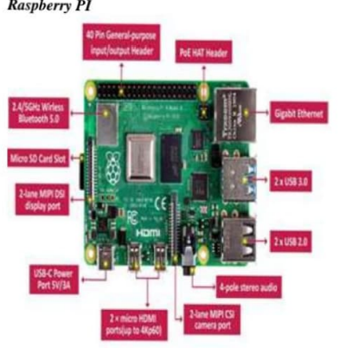



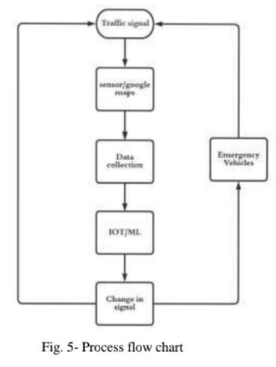

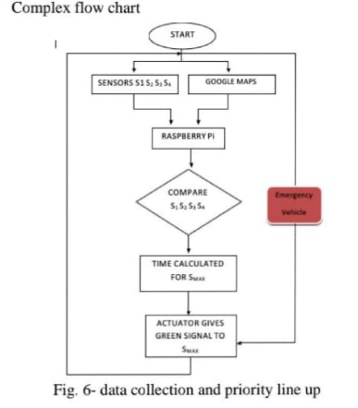

TRAFFIC MANAGEMENT SYSTEM

INTRODUCTION:

Here is a sample code which I have created using html, css, and javascript to create a website for traffic management system.

SAMPLE CODE:

<!DOCTYPE html>

<html lang="en">

<head>

<meta charset="UTF-8">

<meta name="viewport" content="width=device-width, initial-scale=1.0">

<title>Real-Time Traffic Information</title>

<link rel="stylesheet" href="https://unpkg.com/leaflet@1.7.1/dist/leaflet.css" />

<style>

/* Reset default margin and padding */

* {

margin: 0;

padding: 0;

box-sizing: border-box;

}

body {

font-family: Arial, sans-serif;

background-color: #f0f0f0;

display: flex;

flex-direction: column;

align-items: center;

justify-content: center;

height: 100vh;

margin: 0;

}

h1 {

font-size: 24px;

margin-bottom: 20px;

text-align: center;

}

#map {

height: 60vh;

width: 100%;

border-radius: 5px;

box-shadow: 0 0 10px rgba(0, 0, 0, 0.2);

}

#search-bar {

background-color: white;

padding: 20px;

border-radius: 5px;

box-shadow: 0 0 10px rgba(0, 0, 0, 0.2);

margin-top: 20px;

width: 80%;

max-width: 400px;

}

label, input, button {

margin: 10px 0;

display: block;

}

input {

padding: 10px;

border: 1px solid #ccc;

border-radius: 5px;

width: 100%;

}

button {

background-color: #3887be;

color: white;

padding: 10px 20px;

border: none;

border-radius: 5px;

cursor: pointer;

transition: background-color 0.3s;

}

button:hover {

background-color: #326fa7;

}

</style>

</head>

<body>

<h1>Real-Time Traffic Information</h1>

<div id="search-bar">

<label for="location">From: </label>

<input type="text" id="location" placeholder="Your location">

<label for="destination">To: </label>

<input type="text" id="destination" placeholder="Your destination">

<button id="search-button">Search</button>

</div>

<div id="map"></div>

<script src="https://unpkg.com/leaflet@1.7.1/dist/leaflet.js"></script>

<script>

// Create a Leaflet map instance

var map = L.map('map').setView([37.7749, -122.4194], 12); // Default to San Francisco

// Add a basemap (OpenStreetMap)

L.tileLayer('https://{s}.tile.openstreetmap.org/{z}/{x}/{y}.png', {

maxZoom: 19,

}).addTo(map);

// Function to add a route on the map

function addRoute(location, destination) {

var routeUrl = `https://www.mapquestapi.com/directions/v2/route?key=QwNMrtsZNUVQXERv9agY4GfMbXjZ5tXT&from=${location}&to=${destination}`;

fetch(routeUrl)

.then(function(response) {

return response.json();

})

.then(function(data) {

if (data.info.statuscode === 0) {

var coordinates = data.route.shape.shapePoints;

var polyline = L.polyline(L.Polyline.fromEncoded(coordinates), { color: 'blue' }).addTo(map);

map.fitBounds(polyline.getBounds());

} else {

alert("Route not found. Please check your input.");

}

});

}

// Event listener for the search button

document.getElementById('search-button').addEventListener('click', function() {

var location = document.getElementById('location').value;

var destination = document.getElementById('destination').value;

addRoute(location, destination);

});

</script>

</body>

</html>

CODE EXPLANATION:

The provided HTML and JavaScript code is for a web page that allows users to input a source (From) and a destination (To), and then displays the route between these two locations on a map using Leaflet, a popular open-source mapping library. Here's an explanation of the code:

HTML Section:

1. The HTML document is structured with the usual **<!DOCTYPE>**, **<html>**, **<head>**, and **<body>** elements.
2. Inside the **<head>**, metadata like character set and viewport settings are defined, and the web page's title is set to "Real-Time Traffic Information."
3. The page loads the Leaflet CSS by including the **<link>** tag for the Leaflet CSS from a content delivery network (CDN).
4. Custom styles are defined within a **<style>** element. These styles apply to various elements on the page to improve its appearance and layout. This includes resetting default margin and padding, setting a background color, styling the search bar, and more.

JavaScript Section:

1. The JavaScript code is wrapped inside a **<script>** element at the bottom of the HTML document to ensure it runs after the page is loaded.
2. It starts by creating a Leaflet map instance with **L.map('map')** and sets its initial view to San Francisco (latitude 37.7749, longitude -122.4194) with a zoom level of 12.
3. A base map from OpenStreetMap is added to the map using **L.tileLayer**. This provides the underlying map data for visualization.
4. The **addRoute** function is defined to fetch and display a route on the map. It takes the "From" (location) and "To" (destination) as input.
5. Inside the **addRoute** function:
6. A URL is constructed with the source and destination locations, and a MapQuest API key.
7. A **fetch** request is made to the MapQuest Directions API to obtain the route information.
8. When the response is received, it's parsed as JSON, and the code checks if the status code (**data.info.statuscode**) is 0, which indicates a successful route retrieval.
9. If the route is found, it retrieves the route's shape coordinates from **data.route.shape.shapePoints**. It creates a polyline on the map using Leaflet to visualize the route and adjusts the map view to fit the bounds of the polyline.
10. If the route is not found (status code is not 0), an alert is shown indicating that the route was not found. This handles cases where the input locations are not valid.
11. An event listener is added to the "Search" button. When the button is clicked, it triggers the **addRoute** function with the values entered in the "From" and "To" input fields.

Overall, this code provides a simple web application that allows users to search for routes between two locations and visualizes the route on a map using Leaflet. Make sure to replace the API key with your own when you deploy the application.

CONCLUSION:

* We use the Leaflet library for mapping, which is a popular open-source alternative to Mapbox.
* We load the OpenStreetMap as the base map.
* We make use of the MapQuest Open Traffic Data API to fetch traffic incidents data (you need to replace **'YOUR_MAPQUEST_API_KEY'** with your actual MapQuest API key).
* You should implement the logic to process and display the traffic data on the map as needed. This could involve adding markers, popups, or other visual elements to represent traffic incidents.
* Remember to obtain your MapQuest API key and adapt the traffic data handling according to your specific requirements.